Projectile Motion:
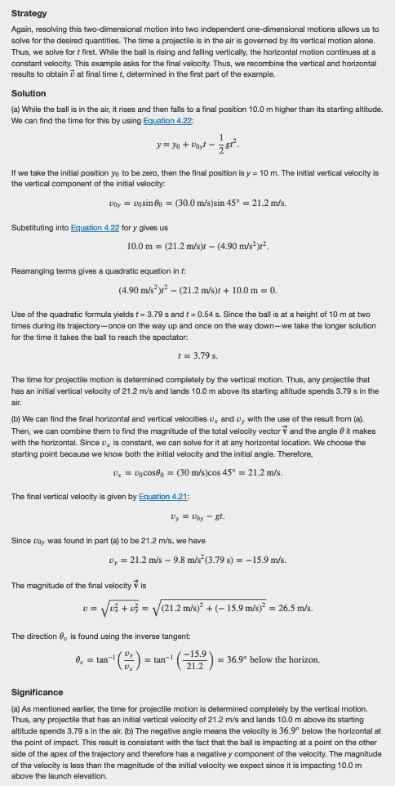
Relative and Circular Motion:
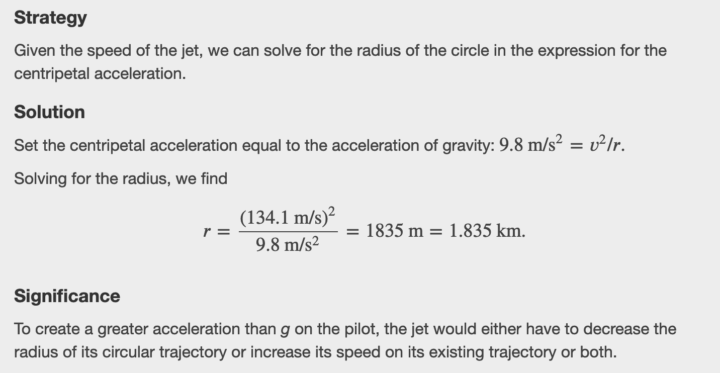

Newton's Laws:
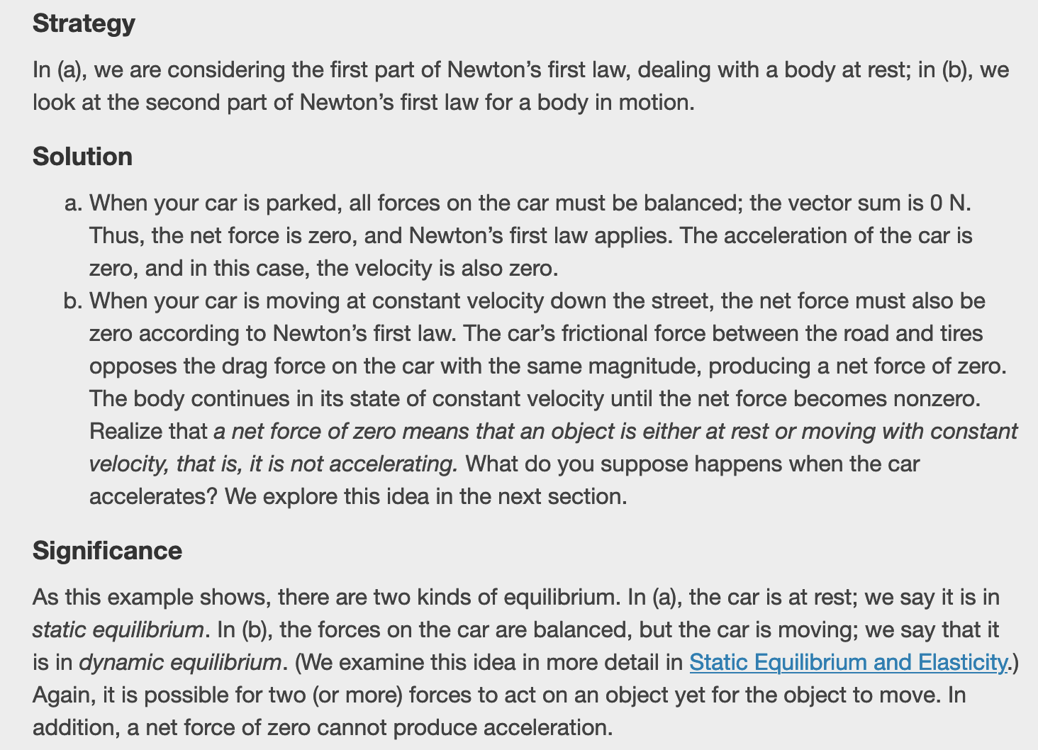

Free Body Diagrams:
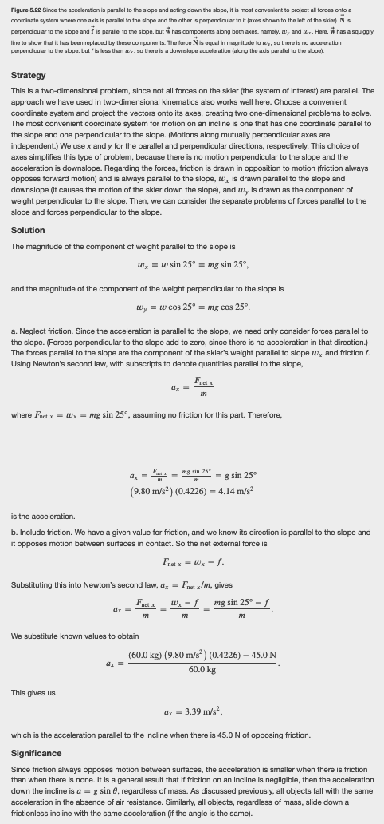
Springs and Friction:

Figure 5.29 A spring exerts its force proportional to a displacement, whether it is compressed or stretched. (a) The spring is in a relaxed position and exerts no force on the block. (b) The spring is compressed by displacement Δ𝐱⃗ 1 of the object and exerts restoring force −𝑘Δ𝐱⃗ 1. (c) The spring is stretched by displacement Δ𝐱⃗ 2 of the object and exerts restoring force −𝑘Δ𝐱⃗ 2.

Work-Energy Theorem:
